**EXPERIMENT 06**

**Implementation of a 2 to 4 Decoder**

**Objectives:**

Implementation of a 2 to 4 decoder using basic gates.

**Equipment use:**

Trainer, IC74LS04 (NOT), 74LS11 (Three input AND gate).

**Background Theory:**

A decoder is a combinational circuit that converts binary information from “n” codes to “2n” (two raised to the power n) unique outputs. They can be 2 to 4, 3 to 8, 4 to 16 etc. It has a lot of applications. There are many scenarios in which we must use such devices.

**Lab Tasks:**

* Write truth table for a 2 to 4 decoder with enable bit in it.
* Draw the gate diagram of a 2 to 4 decoder.
* Implementation of a 2 to 4 decoder using three input AND gate with enable bit as active low and verify with truth table.
* For three input AND gate use 74LS11.

**Procedure:**

Fill in the truth table for a 2 to 4 decoder with an active low enable bit:

|  |  |  |  |  |  |  |
| --- | --- | --- | --- | --- | --- | --- |
| **E** | **S1** | **S0** | **D3** | **D2** | **D1** | **D0** |
| 0 | 0 | 0 | 0 | 0 | 0 | 1 |
| 0 | 0 | 1 | 0 | 0 | 1 | 0 |
| 0 | 1 | 0 | 0 | 1 | 0 | 0 |
| 0 | 1 | 1 | 1 | 0 | 0 | 0 |
| 1 | X | X | X | X | X | X |

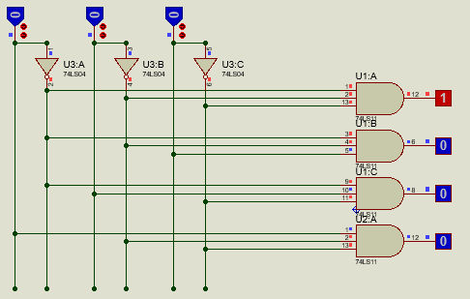

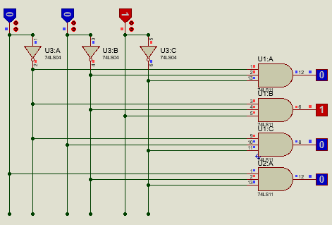

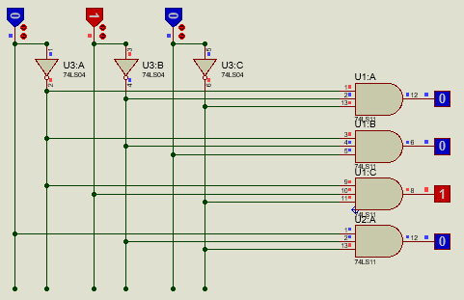

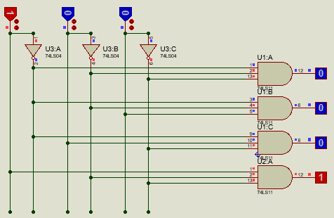

**Pin configuration of 74LS11:**

Following is the pin diagram of three input AND gate IC:

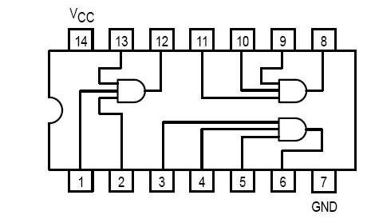

Following is the truth table for three input AND gate IC:

|  |  |  |  |
| --- | --- | --- | --- |
| **INPUTS** | | **OUTPUTS** | |
| **A** | **B** | **C** | **Y** |
| X | X | L | L |
| X | L | X | L |
| L | X | X | L |
| H | H | H | H |

H=HIGH Logic level

L=LOW Logic level

X=Either LOW or HIGH Logic level

**CIRCUIT DIAGRAM:**

Draw a 2 to 4 decoder with active low pin:

